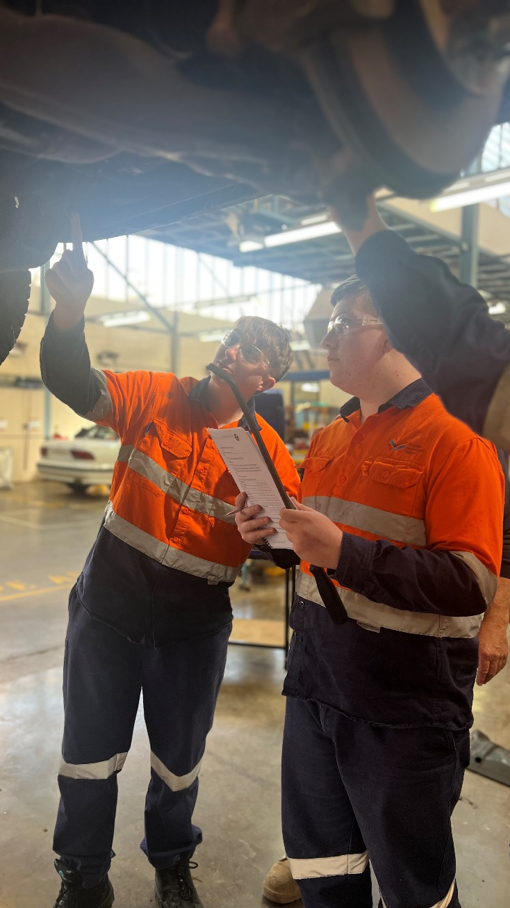
ACEE
Automotive, Construction, Electrotechnology,
Engineering

ACEE
Automotive, Construction, Electrotechnology,
Engineering

Description:
ACEE is a specialist Industry Pathways Program (IPP) for students interested in one of the following careers:
- Automotive: Light Vehicle and Diesel
- Construction: Building, Carpentry, Cabinet Making and Bricklaying
- Civil Construction: Mining, Mineral Exploration, Drilling and Construction
- Electrotechnology: Electrician
- Engineering: Boiler Maker, Fitter & Turner and Metal Fabrication

The program is designed to provide students with the skills, experience and capabilities to increase employment/School-Based Apprenticeship opportunities, through a project-based learning approach. Students will engage in community projects and work placements.

Entry requirements:
- Pass grade in year 10 EIF (Exploring Identities and Futures), English and Maths
- C grade average in subjects
- 80% attendance
- Positive behaviour for learning within school
- Successful participation in the VETRO (VET Readiness Orientation)
- Evidence of Industry Immersion exploring the identified pathway
- Signing of the Code of Conduct
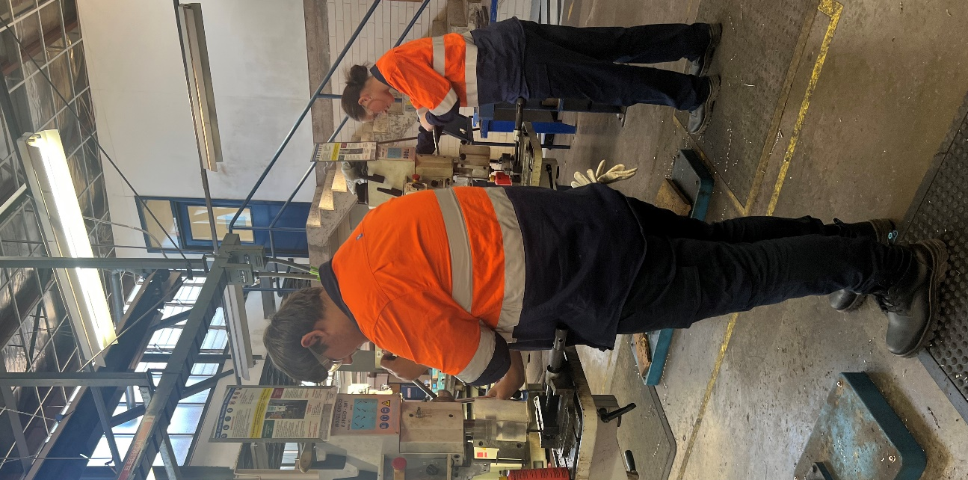
- Completion of enrolment forms
- Participate in interview application process

Entry requirements at the discretion of the college

SACE/ATAR attainment:
Estimated 50 VET credits at SACE Stage 1.
This IPP course cannot be used to gain an ATAR.
Anticipated VET duration: 12 months

ACEE
Automotive, Construction, Electrotechnology,
Engineering

Curriculum on Offer
ACEE Year 1 (year 11)
1 | Essential English
2 | Essential / General Mathematics
3 | Material Solutions (Technologies)
4 | Integrated Leaning (Physics, Business, Health/Fitness)
5 | Community Studies
6 | AIF (Activating Identities and Futures)
7 | VET stream:  Certificate II in Automotive  Certificate II in Construction  Certificate II in Electro-technology  Certificate II in Engineering (welder/fitter)  Certificate II in Resources and Infrastructure Work Preparation (Civil Construction)
ACEE Year 2 (year 12) (Non ATAR)
1 | Integrated Learning (Health/Fitness)
2 | Material Solutions (Technologies)
3 | Community Connections (Workplace Practices)
4 | Mentoring
5 | Study
6 | VET stream:  Certificate II in Automotive  Certificate II in Construction  Certificate II in Electro-technology  Certificate II in Engineering (welder/fitter)  Certificate II in Resources and Infrastructure Work Preparation (Civil Construction)  Or  Study

VET Certificates are subject to change depending on RTO scope.

