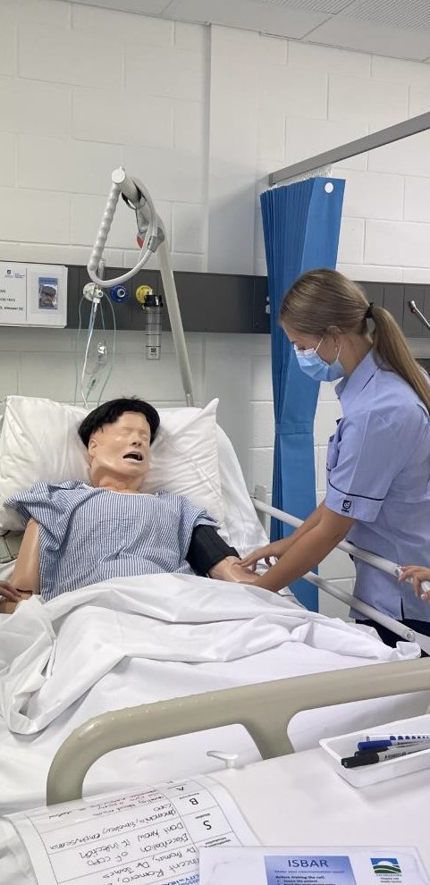
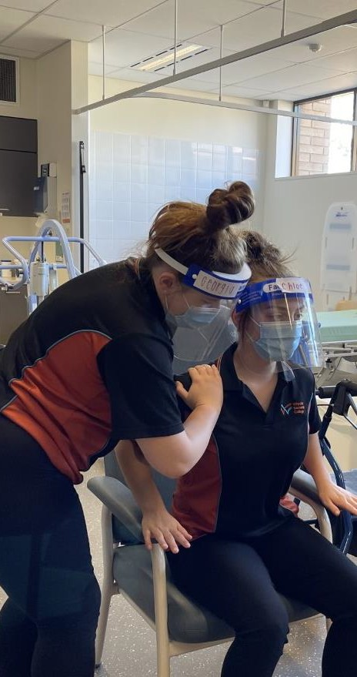

AHEAD
Aged, Health, Education and Disability

Description:
AHEAD is a specialist Industry Pathways Program (IPP) for students interested in one of the following careers:
- Disability Support
- Education (SSO, Early Childhood, preschool, primary and secondary)
- Aged Care
- Nursing / Midwifery
- Allied Health (Social Worker, Speech Pathologist, Psychologist
- etc)

The program is designed to have a project-based learning approach with a focus on the Health and Education sector. Students facilitate the operation of the Whyalla Secondary College crèche and events held within the school and community. Students have the opportunity to engage in community projects and work placements.

Entry requirements:
- Pass grade in year 10 EIF (Exploring Identities and Futures), English and Maths
- C grade average in subjects
- 80% attendance
- Positive behaviour for learning within school
- Successful participation in the VETRO (VET Readiness Orientation)
- Evidence of Industry Immersion exploring the identified pathway
- Signing of the Code of Conduct
- Completion of enrolment forms
- Participate in interview application process

Entry requirements at the discretion of the college

SACE/ATAR attainment:
Estimated 50 VET credits at SACE Stage 1.
This IPP course can be used to gain an ATAR.

Anticipated VET duration: 12-18 months

AHEAD
Aged, Health, Education and Disability

Curriculum on Offer
AHEAD Year 1 (year 11)
1 | Essential English
2 | Essential Mathematics
3 | Health and Wellbeing
4 | Cross Disciplinary Studies (Child Studies/Biology)
5 | AIF (Activating Identities and Futures)
6 | VET stream:  Certificate II in Health Pathways (12 months)  Certificate III in Early Childhood Education and Care (18 months)  Certificate III in Education Support (18 months)  Certificate III in Individual Support (Aged care/Disability) (18 months)
AHEAD Year 2 (year 12) (ATAR Optional based on pathway)
1 | Essential English
2 | Health and Wellbeing
3 | Cross Disciplinary Studies (Child Studies/Biology)
4 | Study
5 | VET stream:  Certificate II in Health Pathways  Continuing from Year 11:  Certificate III in Early Childhood Education and Care  Certificate III in Education Support  Certificate III in Individual Support (Aged care/Disability)  Or  Study

VET Certificates are subject to change depending on RTO scope.

