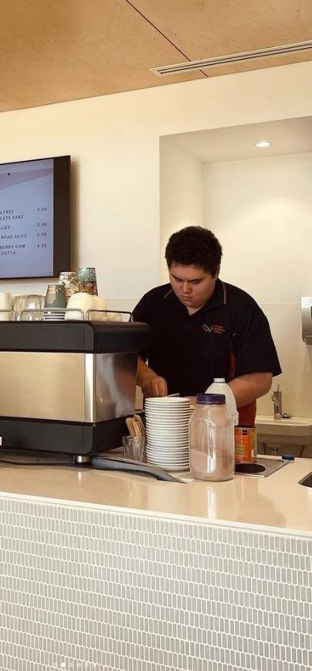
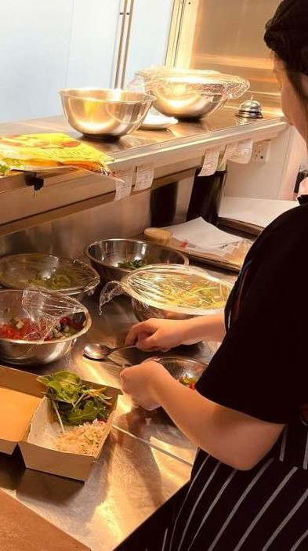

CHAT
Cookery, Hospitality and Tourism

Description:
CHAT is a specialist Industry Pathway Program (IPP) for students interested in one of the following careers:
- Food and Beverage
- Cookery
- Tourism
- Business / Event Management
- Marketing

The program is designed to have a project-based learning approach with a focus on business and enterprise management. Students are responsible for the operation of the Whyalla Secondary College onsite café and catering for events held within the school and community.

Entry requirements:
- Pass grade in year 10 EIF (Exploring Identities and Futures), English and Maths
- C grade average in subjects
- 80% attendance
- Positive behaviour for learning within school
- Successful participation in the VETRO (VET Readiness Orientation)
- Evidence of Industry Immersion exploring the identified pathway
- Signing of the Code of Conduct
- Completion of enrolment forms
- Participate in interview application process

Entry requirements at the discretion of the college

SACE/ATAR attainment:
Estimated 50 VET credits at SACE Stage 1.
This IPP course can be used to gain an ATAR.

Anticipated VET duration: 12 months

CHAT
Cookery, Hospitality and Tourism

Curriculum on Offer
CHAT Year 1 (year 11)
1 | Essential English
2 | Essential Mathematics
3 | Material Solutions (Food)
4 | Food and Hospitality
5 | Community Studies
6 | AIF (Activating Identities and Futures)
7 | VET stream:  Certificate II in Cookery
 | CHAT Year 2 (year 12) (ATAR Optional based on pathway)
1 | Integrated Learning (Tourism)
2 | Material Solutions (Food)
3 | Industry Connections
4 | Food and Hospitality
5 | Study
6 | VET stream:  Certificate II in Cookery  Or  Study

VET Certificates are subject to change depending on RTO scope.

