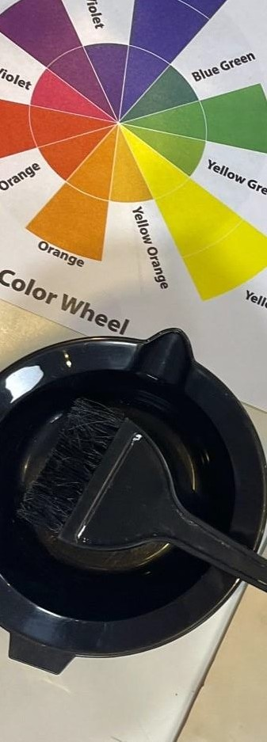
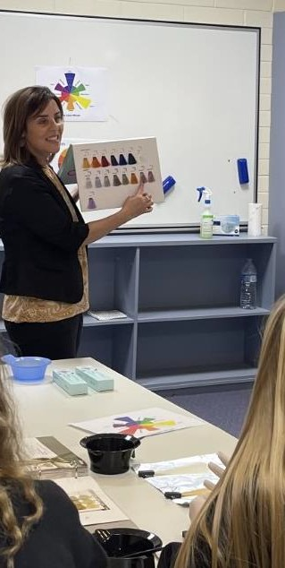

Certificate II in

Salon Assistance

Description:
Embark on your career in hairdressing as you learn about salon services and protocols with this hands-on course. Develop your people skills in greetings clients in the salon. Learn the basics of shampooing and basin services, head and shoulder massage techniques, and build your knowledge of salon protocols.
Gain a range of practical skills in braiding techniques, drying and styling hair. Learn about stock handling in the salon, visual merchandising, and client sales and advice. Graduate from the course ready to join a creative and professional team as a salon assistant or as a pathway to a hairdressing apprentice.
Employment outcomes are to gain an apprenticeship in Hairdressing, continue studying the Certificate III in Hairdressing or work as a Salon assistant in the retail or beauty industry.

Entry requirements:
- Pass grade in year 10 EIF (Exploring Identities and Futures), English and Maths
- C grade average in subjects
- 80% attendance
- Positive behaviour for learning within school
- Successful participation in the VETRO (VET Readiness Orientation)
- Evidence of Industry Immersion exploring the identified pathway
- Signing of the Code of Conduct
- Completion of enrolment forms
- Participate in interview application process

Entry requirements at the discretion of the college

SACE/ATAR attainment:
45 Credits at SACE Stage 1
This VET course cannot be used to gain an ATAR.

Anticipated duration: 12 months.

Certificate II in
Salon Assistance

National Code | Unit Name | Nominal Hours
Core
SHBXIND002 | Communicate as part of a salon team | 30
SHBXIND001 | Comply with organizational requirements within a personal services environment | 45
SHBXCCS001 | Conduct salon financial transactions | 25
BSBWHS201 | Contribute to health and safety of self and others | 20
SHBHDES001 | Dry hair to shape | 40
SHBXCCS003 | Greet and prepare clients for salon services | 10
SHBHIND001 | Maintain and organise tools, equipment and work areas | 20
SHBHBAS001 | Provide shampoo and basin services | 40
Elective
SIRRMER001 | Produce visual merchandise displays | 35
SHBHBAS002 | Provide head, neck and shoulder massages for relaxation | 20
SHBXCCS004 | Recommend products and services | 20
SHBHIND002 | Research and use hairdressing industry information | 15

VET Certificates are subject to change depending on RTO scope.

