Late to Class and Truancy Procedure

Overview
To ensure a consistent approach is taken to follow up late and truanting students.
Scope
This procedure applies to all Whyalla Secondary College students.
Detail
If a student who was present at school (on the current day) and is not in class, the teacher is to notify Student Services immediately. Student Services will check common areas, Centacare/Interoception, library and music timetables etc. If the student is not located, information is added to the truancy record spreadsheet, noting the time. Behaviour leader on duty is notified to begin searching the College. The following then applies:
High Risk Student  Exercise judgement after 10 minutes | Teacher will notify student services that the student is not in class and that they are unaccounted for.  Student Services will:  - Inform the wellbeing leader and Leader on Behaviour Duty who escalates tracking the missing student  - Advise all staff by email (photo attached) to ‘look out’ and advise if the student is sighted  - Attempt to phone parent / caregiver if first two steps are unsuccessful  All staff continue to ‘look out’ and advise student services if the student is sighted.  All staff are notified by email from student services if and when the student is located.  Please note:  The list of STUDENTS IDENTIFIED AS HIGH RISK with brief details, and a photo will be:  - Updated in Daymap (Colour code next to name)  - Available in the Teams files  - Made explicit in relief teacher notes
Late to class  Student arrives but they are late  Up to 20 minutes late for class  More than 20 minutes, follow truancy process below. | Teacher will:  - Notify student services that student has not arrived to class and has been unaccounted for.  Student services will:  - Add to truancy spreadsheet and phone leader on duty  When the student arrives in class teacher will:  - Notify student services that they have now arrived. Student services will pass this information on to leader on duty  - Update class roll as ‘L- late for class’  - Create a behaviour record on Daymap under truancy  - Arrange make up time by keeping the student in at a break (classroom detention, community service)  For repeated instances teacher to notify parents, issue consequence, create a Daymap behaviour record and seek leadership support if students refusing to complete consequences set by teacher.
Leaves class  Student leaves during the lesson without permission | Teacher will:  - Notify student services that a student has left class and is unaccounted for.  Student services will:  - Assess the situation. If student is identified as high-risk – refer above  - Add to truancy spreadsheet and phone leader on duty
If the student returns to class teacher will:
- Notify student services that they have returned.
- Create a behaviour record on Daymap under truancy
- Aarrange make up time by keeping the student in at a break (classroom detention, community service)
- If the student has been unaccounted for 20 minutes or more, update class roll as ‘LTR- left, truant, returned’
- Refer to leadership for behaviour follow up.
Student services will: pass this information on to leader on duty that the student has returned.
If the student remains unaccounted for, after 20 minutes or more, and does not return to class, follow the truancy process below.
For repeated instances teacher to notify parents, issue consequence, create a Daymap behaviour record and seek leadership support if students refusing to complete consequences set by teacher.

Truancy  Student does not arrive to class or has been unaccounted for, for 20 minutes or more | Teacher will:  - notify student services that 20 minutes has passed and they have not arrived or returned and have been unseen.  - mark the roll using ‘N- truancy’ code.  Student services will:  - Send a text to the parent / caregiver advising student missing, whereabouts unknown  - Enrol the student in a Lunchtime Detention for the next day and fill in a detention slip (Cards will be issued during care group)  - Enter Truancy Record on Daymap  - Check detention list each morning and re-schedule those students who are absent from school by the end of lesson 4  Leadership:  - Year level leader on duty will supervise Detention  - mark attendance  - Issue Take-home for students who are present at school but have not attended detention  - Relevant Year level leader will monitor and track student truancy, detention and Take-homes on the behaviour spreadsheet “truancy” tab  - Organise an intervention meeting with parent/caregiver, student and teaching team for students who  - have 2 Take-home’s for not attending detention  - Or 3 detentions or truanted lessons (unaccounted for 20 minutes or more)  - Issue 2-day external suspension for students who reach 5 detentions/truanted lessons (unaccounted for 20 minutes or more) within a period of 10 school days  - Reconnection meeting with Assistant Principal will address behaviour  *Maximum of one detention given per day, even if truant more than once in a day.
Detentions issued for truancy: Staff process | Student services will enrol students who have been truant and unseen for 20 minutes of more into a detention the following day.  Student services of each relevant year level will update the detention roll to reflect those students who are absent from school on the day of their detention, rescheduling the students into a detention for the next day, by lunch time.  Scheduled detention leader will  - Mark the detention roll to reflect students who have attended their scheduled detention in the first 15 minutes of their duty  - Make calls home for those students who are at school but have not attended their scheduled detention, informing parent/caregiver of Take-home being issued and get details of how students will be getting home  (Assistant principal on roving duty will assist if necessary)  - Email all student services, other year level leaders and assistant principals the details of which students have been issued a take-home and which they have been unable to get in contact with  Student services will  - Collect students who have been issued take homes for not attending their scheduled detention and pass on details of how they will be getting home  - Call the leader on behaviour duty to issue take-homes for any students the detention leader was unable to get in contact with  Leader on behaviour duty to issue take-homes for any students the detention leader was unable to get in contact with  Year level leader will update details of daily updates spreadsheet for students who have received detention, had multiple truancy record in one day (more than 20 minutes unsighted), been issued take-home for not attending scheduled detention, 3-day suspension for 5 detentions or truancies of 20 minutes or more

*PLEASE NOTE: For all scenarios above, if the student arrives to class, teachers advise Student Services as soon as possible.

Role | Responsibilities
Teachers | - Notify Student Services of missing students  - Notify Student Services if students later arrive to class  - Report immediately to student services if you know the location of a missing high-risk student  - Arrange make up time and detentions for late students  - Enter Daymap behaviour records for ‘late to class’, ‘left class’ for less than 20 minutes  - Mark roll with codes: L, #LTR, N  - Refer subsequent incidents of truancy to leadership for further follow up
Student Services | - Add missing students to behaviour spreadsheet and notify leader on duty  - Advise staff by email of missing high-risk students  - Text and phone parents/ care givers of high-risk students who cannot be located  - Text parents after 20minutes to notify whereabouts unknown  - Add students to 1x detentions on Daymap when SMS is sent  - Issue a detention card per student and distribute the next day  - Add a Truancy Daymap Record  - Check detention list each morning and re-schedule those students who are absent from school by the end of lesson 4
Year level Leaders | - Year level leader on duty will supervise Detention and mark attendance  - Issue Take-home for students who do not attend detention  - Relevant Year level leader will monitor and track student truancy, detention and Take-homes on the behaviour spreadsheet “truancy” tab  - Organise an intervention meeting with parent/caregiver, student and teaching team for students who  - have 2 Take-home’s for not attending detention  - Or 3 detentions or truanted lessons (unaccounted for 20 minutes or more)  - Issue 2-day external suspension for students who reach 5 detentions/truanted lessons (unaccounted for 20 minutes or more) within a period of 10 school days
Assistant Principals | - Monitor student truancy and community service data  - Implement intervention and consequences for those refusing to attend Detention, have repeated truancy or Detention records  - Issue 2-day external suspension for students who reach 5 detentions/truanted lessons (unaccounted for 20 minutes or more) within a period of 10 school days  - Run reconnection meeting with Assistant Principal will address behaviour and complete SDP
Wellbeing Team Leader | - Identify High Risk Students and inform all staff, create Daymap record etc  - Search for missing High Risk students when required
Behaviour Duty Leader | - Try to locate missing students and return them to class  - Enact behaviour consequences as required i.e.: Takehome, suspension

Data record responsibilities
Data source | Staff responsible
Daymap | Teaching staff will enter a daymap Behaviour record under the category of truancy for students who are late to class, leave class for under 20 minutes then return.  Teaching staff will enter a daymap truancy record for students who have been truant for 20 minutes or more.  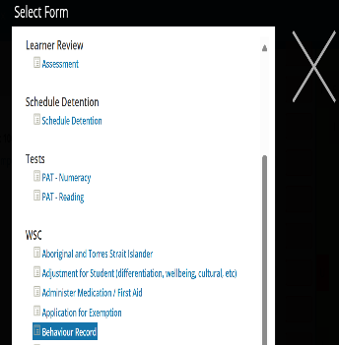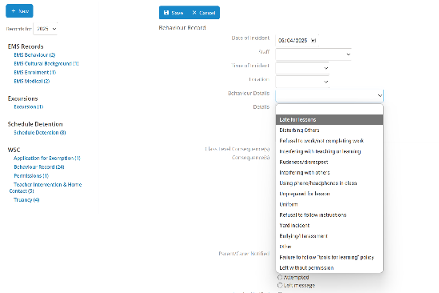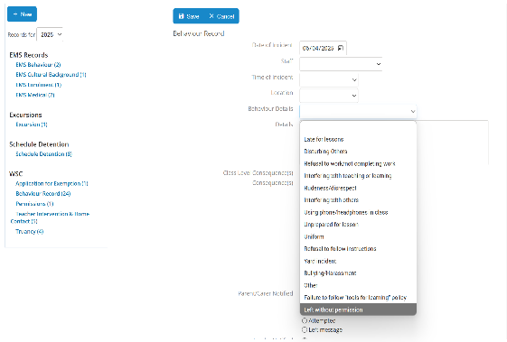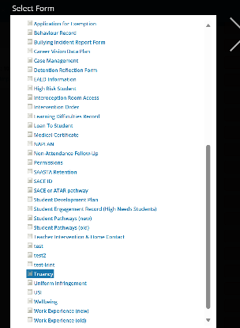  Student services will enrol students who have been truant for 20 minutes or more into a detention  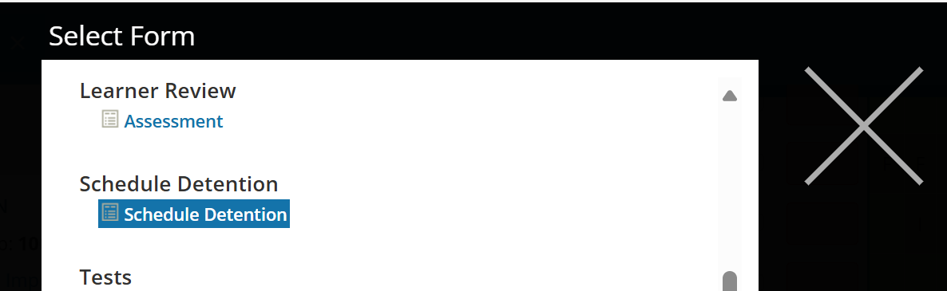
Behaviour Spreadsheet | Student services will enter details on the behaviour spreadsheet under the truancy tab for students who have been reported by teaching staff as present at school but have not arrived to class and have been unsighted. Student services will update record when teacher informs that students has either returned to class or have remained truant for 20 minutes or more.  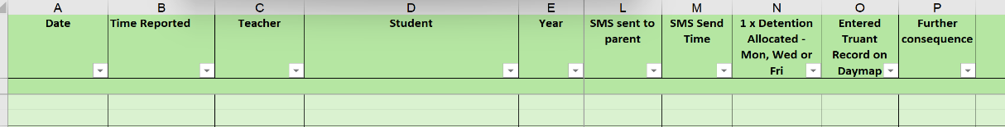Student services will update the behaviour spreadsheet to reflect those students who have been issued with a take-home by the detention leader for not attending their scheduled detention.  Leadership will complete behaviour record details if they have returned the student to class or further consequence has been issued.
Daily updates spreadsheet | Year level leader will add student names to the Daily update's spreadsheet, for their relevant year level, if a student has been issued a detention or had multiple records of truancy for more than 20 minutes within a day.  Year level leaders will add details of Take-homes issued to those students who have not attended 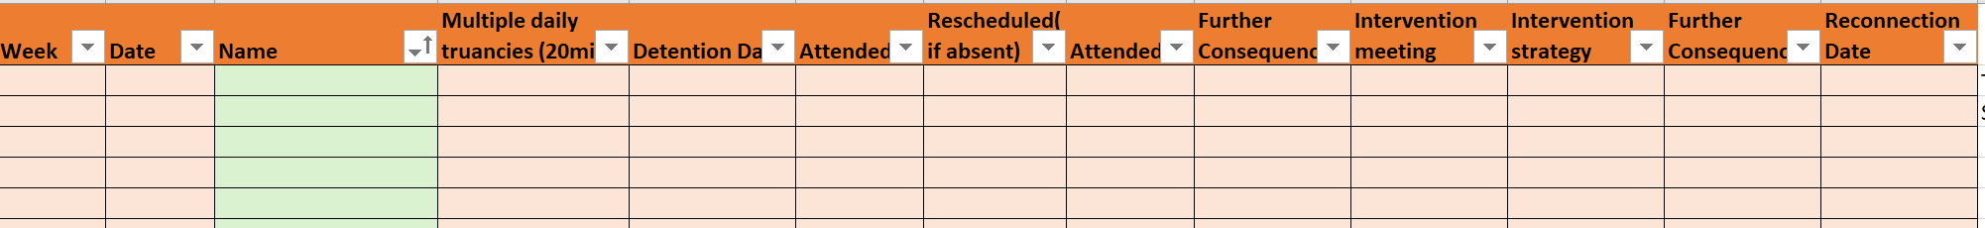

Appendices
Operational Information for Administration Staff
Truancy flow chart
Detention supervision and follow up process for Leaders
Detention reflection for students

