**Overview**This strategy provides an overview of the vision of Entrepreneurial Learning at Whyalla Secondary College. The Entrepreneurial Learning strategy has been developed in support of students, teachers and parents / caregivers.

**Entrepreneurial Learning Strategy**

Whyalla Secondary College supports the vision that students who understand the connections between school, their self and transferrable skills are more likely to have greater engagement and achieve better educational outcomes during and post school. Whyalla Secondary College’s Entrepreneurial Learning strategy is driven by the development of future employability skills and the fail forward mindsets, allowing students to build a resilient approach to learning by finding and resolving real world problems.

Where once large companies stipulated the qualifications and experience they were seeking, today it is much more about employability and entrepreneurial skills, and this is only set to grow.  In fact, research by the World Economic Forum into the skills employers will want in 2020, found the top three to be:

* Analytical thinking and innovation
* Active learning and learning strategies
* Creativity, originality and initiative

Young people need to learn enterprise skills now to prepare themselves for the economy of the future, so they can become job creators, not just job seekers, and navigate more complex careers.

*The Paradigm Shifters: Entrepreneurial Learning in Schools* report (2017) definition of Entrepreneurial minded and learning has inspired the context of this strategy:

|  |  |
| --- | --- |
| **Entrepreneurial minded** | A disposition to think and act entrepreneurially, defined in this initiative as learners whose curiosity leads them to seek out and identify or solve problems that are worth solving. They look at problems as opportunities, rather than as dead ends. They apply their creativity and talents to develop innovative ideas and solutions. They care about the quality of what they produce, embracing mistakes as markers for learning and improvement. They are energised by the potential benefits to others, locally or globally, from what they do and produce. (Michelle Anderson, Bronwyn Hinz and Hannah Matus, 2017) |
| **Entrepreneurial learning** | Often uses project and product oriented learning as a pedagogical strategy. Teaching entrepreneurial education is often viewed as either the teaching about ‘it’ (content based), ‘for it’ (prepare for future entrepreneurs), or as an approach through ‘it’ (process driven) (Dijk & Mensch 2015). Distinct features of entrepreneurial learning include identifying and investigating real world problems and opportunities; creating authentic artefacts (products or services) of value to others; working in teams; and iterative experimentation over an extended period of time (Lackéus 2015). |

**Purpose of the Strategy   
*Did you know?***

* Today’s students will enter an environment of jobs yet to be created, technologies yet to be invented and challenges yet to be imagined.
* Entrepreneurially-minded young people will have the attitudes and skills they need to successfully navigate the challenges and opportunities of an ever changing world.
* Entrepreneurial learning develops entrepreneurial attributes that promote the ability to apply knowledge in complex, unfamiliar and non-routine contexts.
* 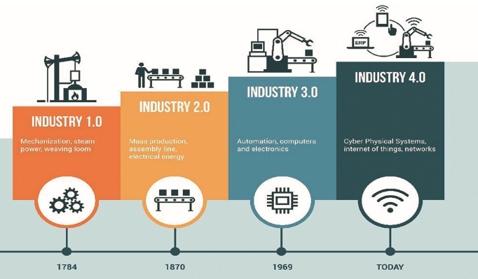Entrepreneurs don’t just start new businesses. They can work in, work for and work with businesses, and help turn them into entrepreneurial ones.
* Entrepreneurial thinkers persist even after an outcome is achieved, continuously seeking new opportunities to be creative and to solve problems.
* To succeed in this ever-changing world, students need to be able to think like entrepreneurs: resourceful, flexible, creative, and global.
* As jobs are transformed by the technologies of the Fourth Industrial Revolution, society will need to reskill more than 1 billion people by 2030.

**Benefits and impacts**

Research and evaluations of entrepreneurial learning have shown some short and long-term benefits for school students in different contexts, including:

* Increased aspirations to be entrepreneurial, with associated increased leadership activities outside school, and more students doing this through their own initiative
* Improved enjoyment and feelings of connectedness to peers and teachers
* Improved student effort (they persist), creativity and agency (they are more pro-active)
* Improved skills to help them manage and adapt to change
* Increased levels of entrepreneurial activity when students feel ownership over the projects they work with
* Improved capabilities, which together are sometimes referred to as ‘life skills’, such as creativity, teamwork and understandings of risk, social responsibility and resilience

(Michelle Anderson, Bronwyn Hinz and Hannah Matus, 2017)

**Vision  
*Are we ready to be a future ready school?***

|  |
| --- |
| **Definition:** A school that is innovative and future-focussed, providing curriculum opportunities for students to engage in learning that links to life. (Futureanything, 2021) |

Entrepreneurial Learning at Whyalla Secondary College is driven by the vision that students in all subjects solve problems and think with an entrepreneurial mind. Whyalla Secondary College is committed to offering subject pathways to support specialised entrepreneurial learning and providing students year 7-12 with entrepreneurial learning that is reflective of the changing nature of work, while equipping students with the knowledge, skills and capabilities needed to become lifelong problem solvers who continue to discover and collaborate.

As educators, when we strive to praise failure, look for grit, and assess the process instead of only the final product we allow students to be empowered to share their learning and processes taken.

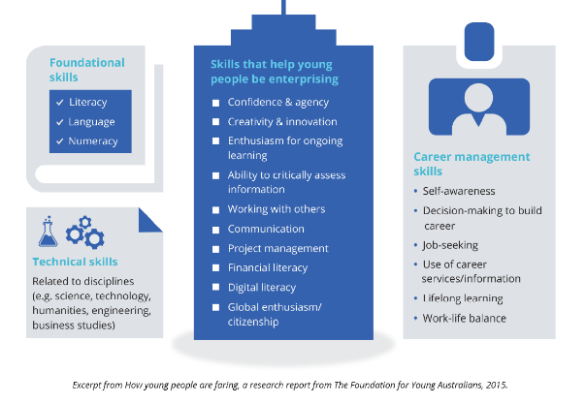Entrepreneurial Learning at Whyalla Secondary College strives to meet the school value of Innovation and developing skills for the future workforce. As a school our educational direction to achieve this involves:

* A whole school emphasis on developing skills such as critical thinking, problem solving, and analysis capabilities of students
* Providing learning opportunities to build skills required by employers, such as the ability to collaborate, work in groups, read social cues, and respond adaptively
* Integrating literacy into education programs that requires students to decode, understand and think critically about sources of evidence
* 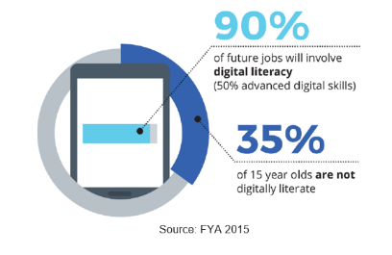Providing interdisciplinary learning experiences that allows students to develop skills and knowledge in a range of subjects across a learning opportunity
* Promoting the benefits and value of entrepreneurial learning, risk-taking and innovation to position students for success
* Creating opportunities for students and teachers to learn with each other.

**Outcomes**

1. Engaging students in learning that develops an entrepreneurial mind-set
2. Embedding entrepreneurial learning in their curriculum offerings
3. Partnering with business and community
4. **Engaging students in learning that develops an entrepreneurial mind-set**[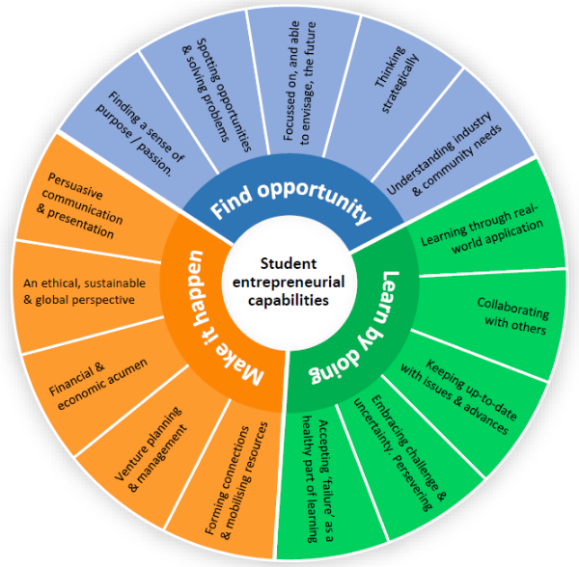](https://prod005-au.sz-cdn.net/heathfieldhs/media/176/190724013455887/600x588/annotation_2019_07_24_110317.png)At Whyalla Secondary College, we see the importance and need for students to develop an entrepreneurial mindset to become resilient and adaptable lifelong learners, students will work towards this by following the entrepreneurial capabilities. Teachers across all Learning Areas will deliver teaching and learning programs that provide students with opportunities to develop their entrepreneurial capabilities and mindset, with a focus on the Critical and Creative Thinking and Personal and Social Capabilities.
5. **Embedding entrepreneurial learning in their curriculum offerings**

In specialised subjects each year, students will engage in a learning environment that not only develops entrepreneurial capabilities, but also uses Design Thinking and Problem Solving processes to develop a solution to an identified class/community and/or global problem, while considering the future skills for employment. Students in an Industry Pathways Program (IPP) will have the opportunity to further develop their understanding of business, the economy and financial literacy through a set subject package linked to their desired pathway.

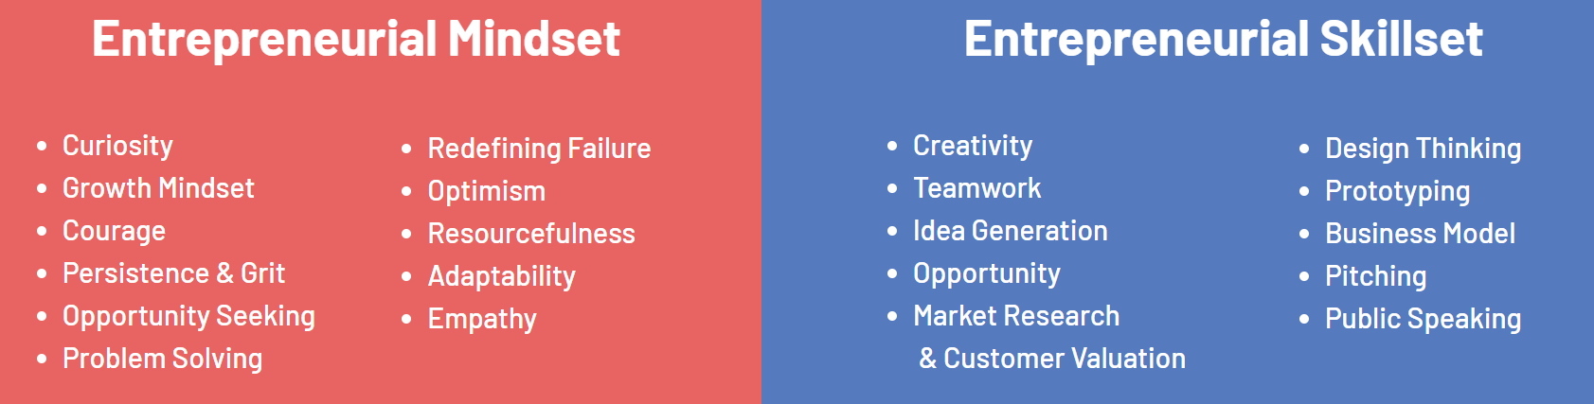

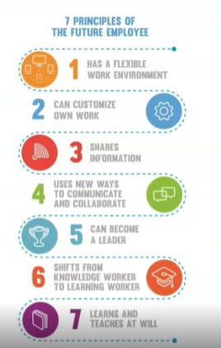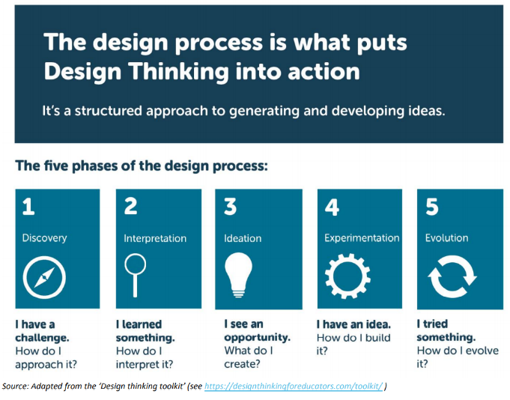

**Entrepreneurial Subjects include:**

**Year 7-8**

* Integrated enquiry across the curriculum
* Challenge days (1 per term)

**Year 9**

* $20 Boss (HASS Economics and Business) +International school connection to share learning (2023)
* Microsoft challenges

**Year 10**

* Economics and Business /Technology: choice subject
  + Shark Tank (Adelaide University program) $1,000 to train the teacher
  + ETSY stall item
  + ASX game
  + Social change or non for-profit organisation connection (Civics and Citizenships)
  + Geography

**Year 11**

* Business Innovation (Stg 1 – elective subject)
* Advancing Technologies (Stg 1 – elective subject)

**Year 12**

* Business Innovation (Stg 1 – elective subject)
* Advancing Technologies (Stg 1 – elective subject)

**Industry Pathways Programs (IPP’S)**

* Business Innovation (Stage 1-2 subject)

Primary schools will also have an opportunity to engage in illumination, facilitated by senior students Year 10-12. Illumination is a place for primary school students to come to Whyalla Secondary College to learn and engage in AI/VR/Electronics and more, in an effort to promote entrepreneurial learning along with the mindset that we solve problems. This environment will also highlight to students STEM learning and pathways.

1. **Partnerships with business and community**

Through subjects, and a range of learning opportunities, there are many opportunities for community and industry mentors to engage with and support students in their learning and career pathways.

***Staff Professional Development***

In support of this strategy the staff at Whyalla Secondary College are committed to professional development, delivered through participating in

* Young Change Agent training Year 7-8
* Future Anything with Learning Area Leaders,
* whole staff visiting Whyalla UniSA ICC hub and Professional Learning Committees (PLC’s).

This is to ensure students are successful with future skills and attitudes, as they understand that students will increasingly be called upon to continually reassess the skills they need to be adaptable lifelong learners.

**Result Measures**

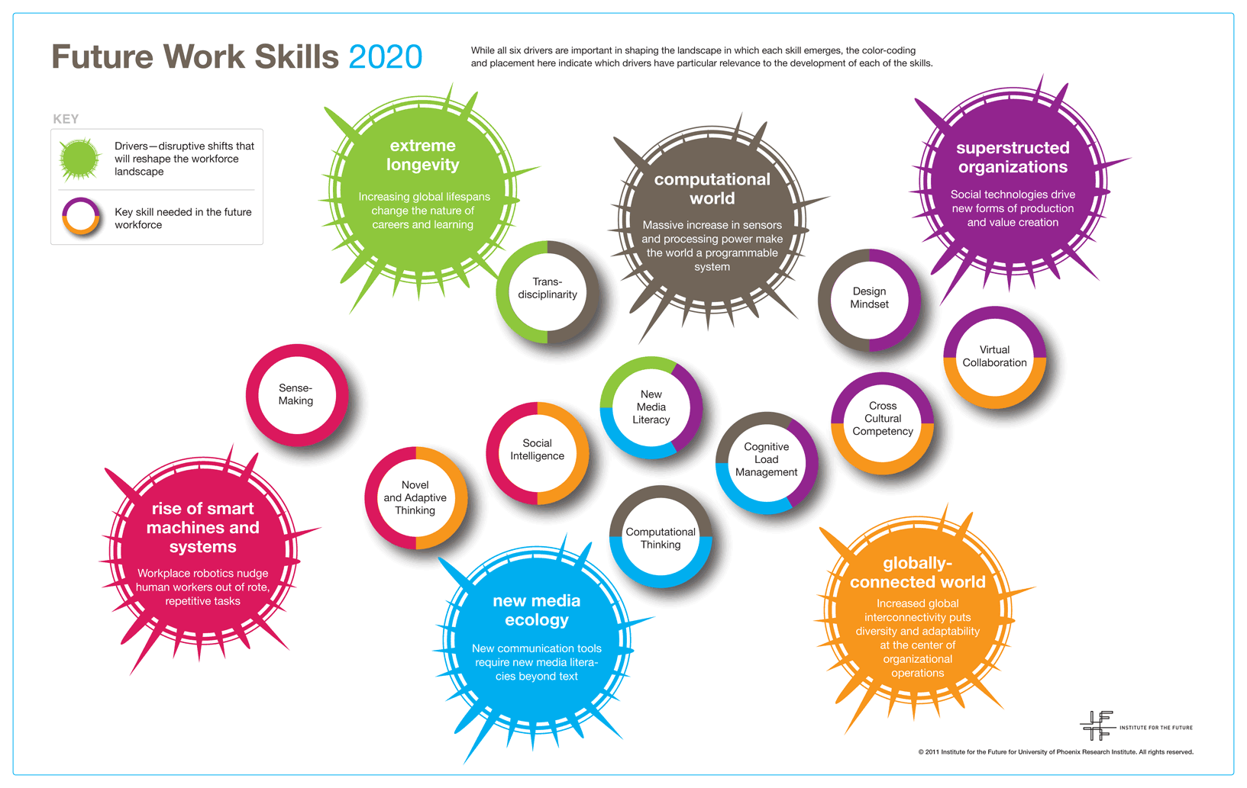Success will be measured by the number of:

* Students enrolled in entrepreneurial subjects
* Students achieve a minimum of a C grade in entrepreneurial subjects
* Teachers trained in entrepreneurial programs and mindsets
* Entrepreneurial activities carried out in the school
* Partnerships with community and businesses
* New businesses formed by graduates of Whyalla Secondary College

**Definitions**

**Supporting Information**

**References**The following has been used as a reference in developing the strategy:

* *South Australia* Entrepreneurial Learning *Strategy (Creating a mindset for world class education)*
* SA priority growth sector; skills and innovation a key area growth (entrepreneurial and creative culture in SA)
* Department for Education *VET for school students Policy*
* Australian Curriculum requirements
* *Students will develop their understanding of the importance and role of enterprising behaviours and capabilities at an individual and business level (local and global).*
* *Encourage students to be adaptable, demonstrate initiative, solve problems and take on leadership roles in all aspects of life.*